UNIT I
- Convert NFA to DFA. Informally describe the language it accepts.
δ | 0 | 1
→p | {p,q} | {p}
q | ∅ | {r}
*r | {p,r} | {q}

- Give non-deterministic finite automata to accept the following language over {0, 1}*
The set of all strings containing either 101 or 110 as a substring
- Construct NFA and DFA for accepting all possible string of zeroes and ones not containing 101 as a substring.

- Construct tabular minimum state automata for following automata.

State/∑ | a | b
→ q 0 | q1 | q5
q1 | q6 | a2
*q2 | q0 | q2
q3 | q2 | q6
q4 | q7 | q5
q5 | q2 | q6
q6 | q6 | q4
q7 | q6 | q2

- Differentiate between NFA and DFA.
- Define Moore machine and Mealy machine . give example of eachone.
- Construct Moore machine for following table.

Present State | a | b
 | state output | State output
q1 | q1 b | q2 a
q2 | q4 b | q4 b
q3 | q2 b | q3 b
q4 | q3 a | q1 b
\
- What is Finite automata? explain working of finite state machine.
- Convert to DFA the following NFA
 | 0 | 1
{p} | {q, s} | {q}
q* | {r} | {q, r}
r | {s} | {p}
s* | Ø | {p}

- Differentiate between Mealy and Moore machine
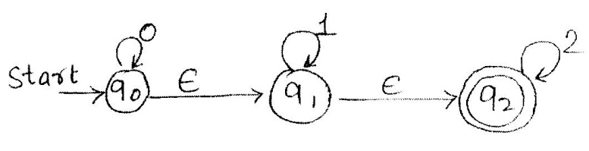





- Consider following NFA with ɛ transitions. Find equivalent NFA without ɛ transitions.
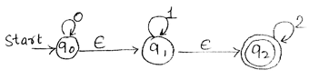

- Construct a Moore machine equivalent to mealy machine M given as
Present state | (next state, output)
 | Input 0 | Input 1
p | r,0 | q,0
q | p,1 | s,0
r | q,1 | p,1
s | s,1 | r,0

- Convert to DFA the following NFA
 | 0 | 1
{p} | {p,q} | {p}
q* | {r} | {r}
r | {s} | Ø
s* | {s} | { s }

- Explain following terms:
- Kleen closure ii) alphabet iii) string

- Construct NFA and DFA for accepting all possible string of zeroes and ones not containing 101 as a substring.

- Design DFA for language over {a, b} for all strings with abb as a substring.

- Construct NFA and DFA for following languages
- L={x ɛ{a,b,c}* : x contains exactly one b immediately following c}
- L={x ɛ (0,1}* : x starting with 1 and |x| is divisible by 3}

- Write applications of FA.

- Construct the minimum state automation equivalent to the transition diagram given as below :

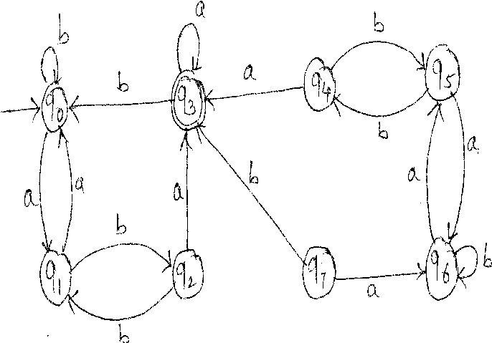

.

- Define DFA and NFA. Explain working of NFA and DFA

